**ANALAYSIS OF RESULT**

**RESULT**

|  |  |
| --- | --- |
| **Dataset** | WILD EDIBLE PLANTS |
| **Number of images** | 3756 |
| **Training Data** | 2629 (70%) |
| **Validation Data** | 563 (15%) |
| **Test Data** | 563 (15%) |
| **Number of Epochs run** | 25 |
| **Optimizer** | SGD |
| **Average Accuracy** | 0.663 |
| **Validation Accuracy** | 0.711 |
| **Average Loss** | 0.958 |
| **Validation Loss** | 0.838 |
| **Batch Size** | 32 |
| **Loss Function** | categorical_crossentropy |
| **Momentum** | 0.9 |
| **Ir** | 0.01 |
| **Decay** | 1e-6 |
| **Nesterov** | True |

**Table representing the result**

**SIMULATIONGRAPH**

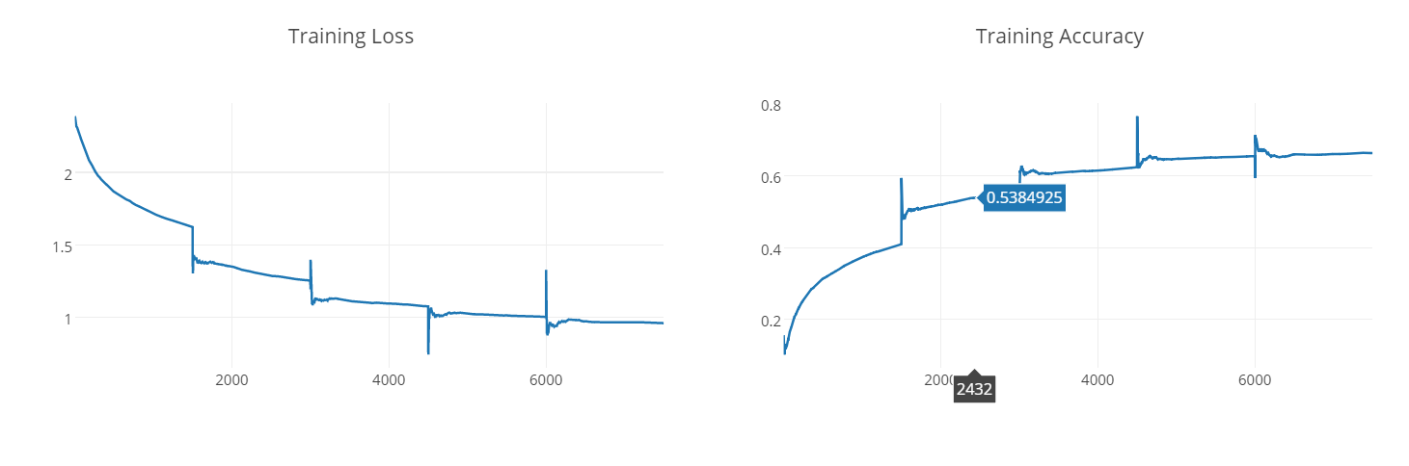

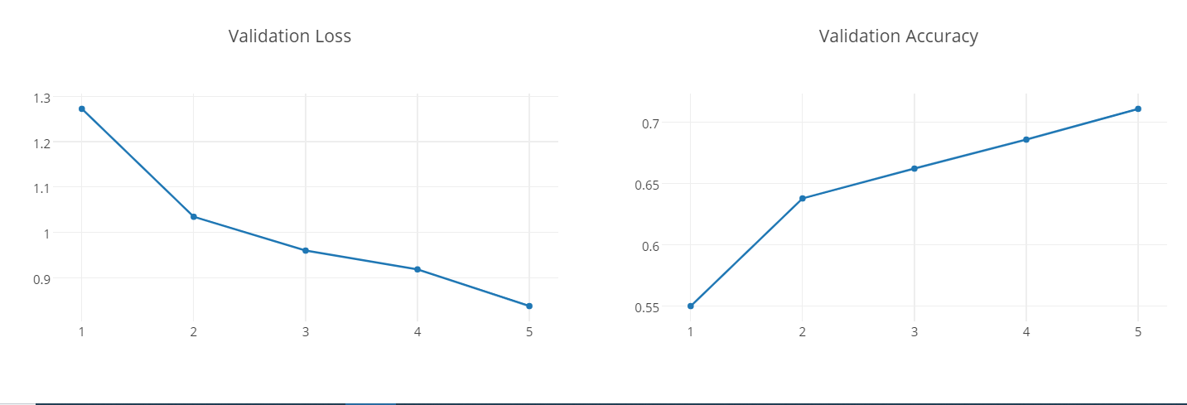

**Simulation Graph**

The simulation graph for a single epoch is obtained and the accuracy is observed. It’s is inferred that accuracy can be increased by increasing the number of epoch.